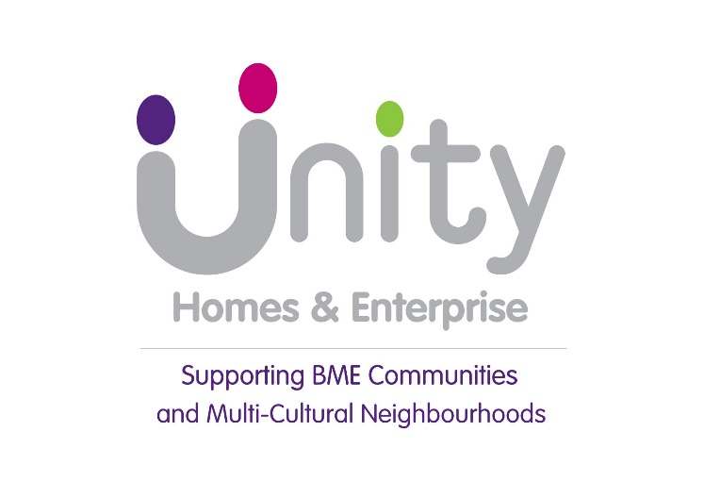
Unity is one of the largest Black & Minority Ethnic (BME) led housing associations, managing over 1,200 properties which are a mixture of affordable rented and shared ownership. Our services are aimed primarily, but not exclusively, at the BME communities of Leeds.

Housing Officer
£25,700 to £31,240
We are looking for a person with Housing Officer experience to join the Housing Services team. You must have a commitment to service delivery and the willingness to work as part of a team delivering housing management services to a range of tenants across Leeds. You must have a great attitude towards customers and a willingness to provide the best possible service.

Requirements:

- Rent arrears, ASB, voids &
lettings experience
- Housing Benefit and/or Welfare
Reform experience
- Excellent communication skills
- Organised with the ability to prioritise
- IT Skills

Application forms and other information must be sourced from our website uha@unityha.co.uk – employment
Paper copies only can be requested via email ann.foster@unityha.co.uk

Closing date for applications is noon on Friday 16 February 2018
The closing date for applications is Friday 6 April 2018

Unity welcomes applications from all sections of the community.

